# HTML – Lesson 2

## How to create hyperlinks

The ……………….. tag defines a hyperlink, which is used to link from …………… to …………………….. An hyperlink is a clickable text that brings the user to ……………………… page.

The most important attribute of the <a> element is the href attribute, which indicates the link's address. The text between the start tag and the end tag is the label of the link.

Example :

By default, links will appear as follows in all browsers:

* An unvisited link is ………………..…… and …………….
* A visited link is …………….……………. and ………………..

## HTML Attributes

HTML elements can have attributes. They provide additional information about HTML elements.

* Attributes provide ………………………………………………………
* Attributes are always specified in ………………………………
* Attributes come in name/value pairs like: …………………………………..

## HTML Example

A small HTML document:

## MISSING ATTRIBUTES – **PRAcTICE**

Using this description, a web browser can display a document with a heading and a paragraph.

|  |  |  |  |
| --- | --- | --- | --- |
| Label | Destination | | HTML code |
| *Go to pnc* | *pnc.html* | *<a href=“pnc.html”>Go to pnc</a>* | |
| Give me |  | <a href=“candy.html”>Give me</a> | |
| My car | ferrari.html |  | |
|  |  | <a href=“movie.html”>Watch</a> | |
| My phone | nokia.html |  | |

## RELATIVE LINKS - **PRACTICE**

Here is a website folder structure. Fill the table with the content of the href attribute if I want to create a link to “destination page” from “source page”.

Example: In the page action.html, a link to cinema.html would be <a href=”**../cinema.html**”>go to cinema</a>

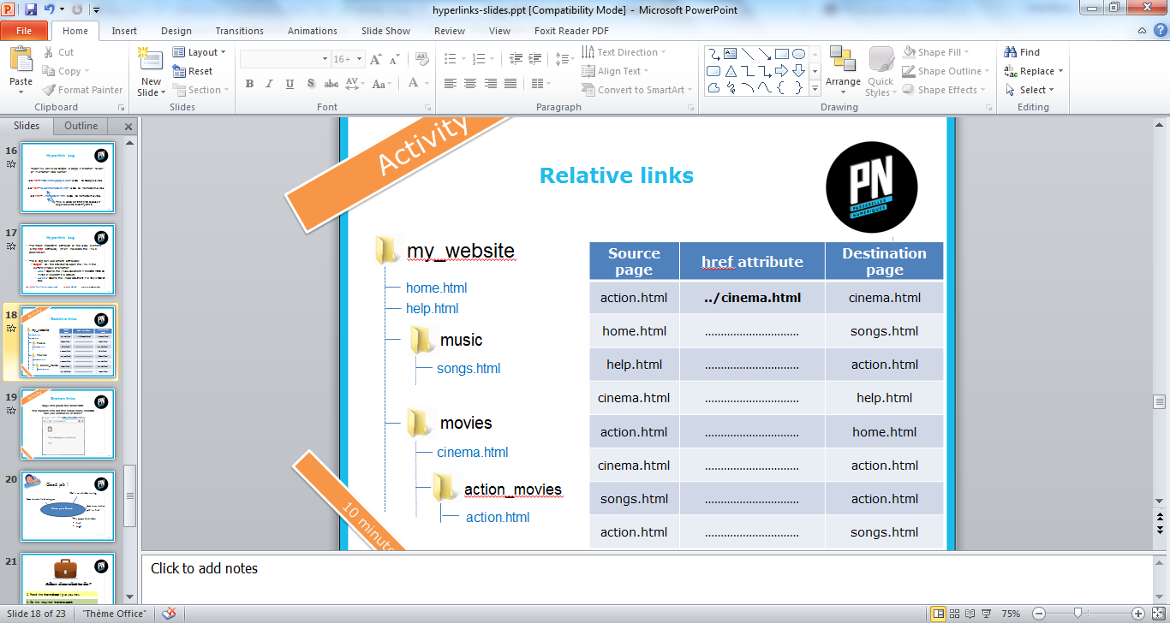

|  |  |  |
| --- | --- | --- |
| **Source page** | **href attribute** | **Destination page** |
| action.html | **../cinema.html** | cinema.html |
| home.html | ………………………… | songs.html |
| help.html | ………………………… | action.html |
| cinema.html | ………………………… | help.html |
| action.html | ………………………… | home.html |
| cinema.html | ………………………… | action.html |
| songs.html | ………………………… | action.html |
| action.html | ………………………… | songs.html |